**The Judicial System of Pakistan**

The country came into existence in 1947 as a result of the partition of India, carried out by the British through the Indian Independence Act. Initially, it was governed by the Government of India Act of 1935. However, the principles outlined in the Quranic teachings, which were revealed centuries ago, regarding the administration of justice, good governance through democratic means, and the establishment of social justice with a strong emphasis on the independence of the judiciary, were incorporated in the Objective Resolution adopted by the Constituent Assembly of Pakistan on March 12, 1949.

The Objective Resolution aimed to make the country a democracy based on Islamic principles of social justice in all aspects of life. The first constitution of Pakistan was drafted by the Constituent Assembly in 1956, and it included the Objective Resolution in its preamble. This can be considered as the fundamental norm of Pakistan's constitution and it highlighted federalism, a parliamentary form of government, an independent judiciary, and a commitment to social welfare.

The preamble of every constitution states that sovereignty over the entire universe belongs to Allah (God) Almighty and that the authority to govern is derived from Him.

Regrettably, a military dictator prevented the implementation of the 1956 constitution and abolished it in 1958, disrupting the democratic system from its infancy. Subsequently, another constitution was drafted in 1962, only to be similarly abolished by another dictator in 1969. Following this, elections were held and a democratic government was established in 1971. This government enacted the constitution in 1973, which was based on democratic principles and included provisions from previous constitutions. It also included a section on Fundamental Rights. However, this constitution also faced obstacles and was abolished by another dictator in 1977, who remained in power for over a decade. Elections were held again in 1988, restoring democracy in the country.

The previous practice of appointing Superior Courts Judges for the High Courts involved the recommendations of the respective Chief Justices, followed by the approval of the Provincial Governor/Chief Minister. The matter would then be sent to the Chief Justice of Pakistan, and final approval would be granted by the President through the Federal Ministry of Law.

However, there has been a complete change in this procedure due to the 18th amendment in the Constitution of Pakistan. Article 175A has been added, which establishes a Judicial Commission consisting of the following members:

1. The Chief Justice of Pakistan as the Chairman.
2. Four senior-most judges of the Supreme Court as members.
3. A former Chief Justice or a former Judge of the Supreme Court of Pakistan, nominated by the Chief Justice of Pakistan in consultation with the four member judges, for a two-year term as a member.
4. The Federal Minister for Law and Justice, the Attorney General for Pakistan, and a Senior Advocate of the Supreme Court of Pakistan nominated by the Pakistan Bar Council, all serving as members for a two-year term.

Now turning our attention to Pakistan, following the restoration of the judiciary, the Chief Justice of Pakistan, in collaboration with other judges and stakeholders, has devised the National Judicial Policy. This policy aims to address the backlog of cases and expedite the resolution of new cases within the courts of Pakistan. To achieve this, Judicial Academies in all four provinces, along with the Federal Judicial Academy in Islamabad, are actively involved in training individuals involved in the administration of justice. These training programs emphasize the methods outlined in the National Judicial Policy to ensure swift dispensation of justice.

Afterwards, the matter will be referred to the Parliamentary Committee, which is composed of eight members - four from the Senate of Pakistan and four from the National Assembly of Pakistan. Out of these four members, there will be representatives from the Treasury Benches, while the remaining four will be nominated by the Leader of Opposition. The Committee will have a time frame of fourteen days to deliberate on the matter once it is approved by the Judicial Commission. If the Committee fails to do so within this period, the nomination will be considered confirmed by the majority.

However, the Parliamentary Committee, with a three-fourth majority, may choose not to confirm a nomination submitted by the Judicial Commission. In such cases, the reasons for their decision will be recorded. Ultimately, the President will give his approval for the appointment through the Ministry of Law.

The power and authority of judicial review are enshrined in the Constitution under Articles 184 (3) and 199 for the Supreme Court and High Courts, respectively. The Supreme Court's jurisdiction in this regard is broader compared to that of the High Courts. The Supreme Court has the authority to take action whenever there is a violation of Fundamental Rights.

Since the restoration of an independent judiciary, the people of Pakistan have turned to it for the resolution of their grievances. In return, the judiciary has actively worked towards transforming Pakistan into an Islamic socialist welfare state, where everyone can enjoy the protection of the law and be treated fairly.

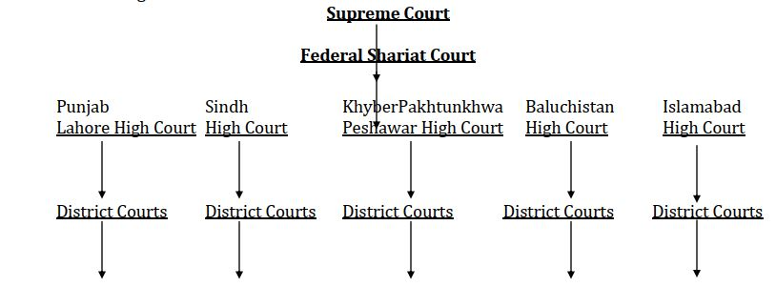

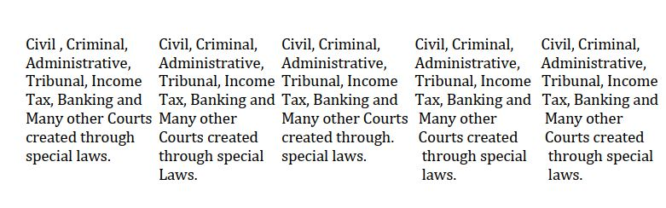

**Supreme Court**

The Supreme Court, the highest court in the country, has the authority to hear cases at both the original and appellate levels, as well as provide advisory opinions. It serves as the ultimate court of appeal and the final interpreter of the law and the Constitution. The decisions made by the Supreme Court are binding on all other courts. The Court is composed of a Chief Justice and several other judges, who are appointed by the President by the procedures outlined in the Constitution. The number of judges, including the Chief Justice, is set at 17 by an Act of Parliament. The Court also has provisions for the appointment of acting judges and ad hoc judges. To be eligible for appointment as a judge of the Supreme Court, a person must have either 5 years of experience as a Judge of a High Court or 15 years of standing as an advocate in a High Court.

**High Coutts**

High Courts are present in every province, with an additional High Court for the Islamabad Capital Territory. Each High Court consists of a Chief Justice and other judges. The Lahore High Court has a fixed strength of 60 judges, the Sindh High Court has 40 judges, the Peshawar High Court has 20 judges, the Balochistan High Court has 11 judges, and the Islamabad High Court has 7 judges. To be eligible for a judge position, one must have either 10 years of experience as an advocate in a High Court, 10 years of service as a civil servant with at least 3 years as a District Judge, or 10 years of experience in a judicial office.

In the past, the process for appointing judges to High Courts involved the Chief Justice of the respective High Court preparing a list of candidates, which was then submitted to the President through the Governor of the province and the Chief Justice of Pakistan. The final selection was made by the President from this list. However, in the case of Al-Jehad Trust v Federation, the Supreme Court ruled that the recommendation of the Chief Justice of Pakistan and Chief Justice of the High Court would be binding on the President, unless there were valid reasons to go against it.

**Federal Sharia Courts**

The Federal Shariat Court comprises of eight Muslim judges, with the Chief Justice among them. The process of appointing judges for the Federal Shariat Court has undergone changes after the 18th and 19th amendments. Previously, the President would appoint judges from either the serving or retired judges of the Supreme Court or a High Court, or individuals meeting the qualifications of a High Court judge. Currently, the appointment of judges for the Federal Shariat Court is also done through the Judicial Commission. This commission is headed by the Chief Justice of Pakistan, with four senior judges from the Supreme Court, one former Chief Justice or retired Supreme Court judge appointed by the Chairman in consultation with the four member judges of the Supreme Court, the Attorney General for Pakistan, the Federal Minister for Law and Justice, the Chief Justice of the Federal Shariat Court, and the most senior judge of the Federal Shariat Court as members. However, when appointing the Chief Justice, the most senior judge of the Federal Shariat Court is not part of this composition. Once approved by the Judicial Commission, a new judge is appointed to the Federal Shariat Court.

**Subordinate Courts**

The Subordinate Judiciary can be broadly categorized into two groups: civil courts, which are established under the Civil Courts Ordinance 1962, and criminal courts, which are created under the Code of Criminal Procedure 1898. Additionally, there are other courts and tribunals of civil and criminal nature that are formed under special laws. The statutes that create these courts define their jurisdiction, powers, and functions. The decisions and judgments made by these special courts can be challenged in the higher judiciary (High Court and/or Supreme Court) through revision or appeal.

The justice sector is funded by the provincial governments. The appointment and conditions of service for judges in the civil and criminal courts are regulated by provincial rules. However, the High Court holds administrative control over these courts. The civil courts include the District Judge, Additional District Judge, Senior Civil Judge, and Civil Judge Class I, II & III. Similarly, the criminal courts consist of the Sessions Judge, Additional Sessions Judge, and Judicial Magistrate Class I, II & III. Their jurisdiction is determined by law in terms of territory and monetary value. Appeals against the decisions of civil courts can be made to the District Judge, while appeasls against criminal court decisions can be made to the Sessions Judge.